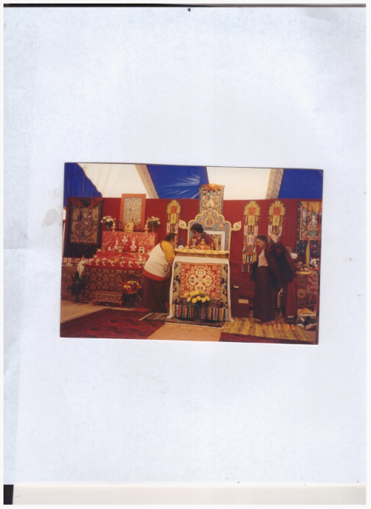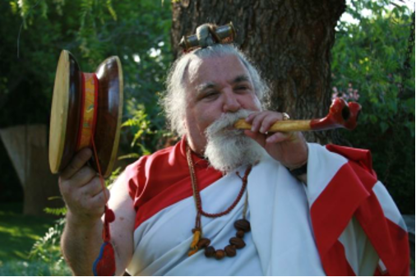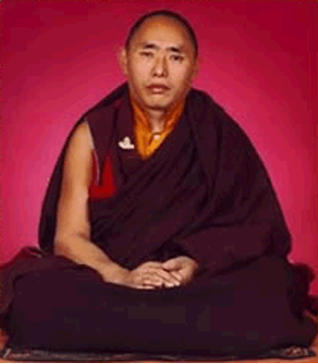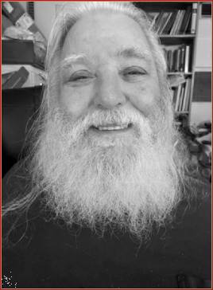

Lyr lama ari bodh rinpoche

In Dzogchen, trekchö (khregs chod) ***means*** "(spontaneous) cutting of tension" or "cutting through solidity." The practice of trekchö reflects the earliest ...

Scan TNR

​​​​<https://www.youtube.com/watch?v=ZCQ5RFC9jG8>

1:11 / 1:02:00

Longchenpa - A Meditation on Four Methods of Resting - Dzogchen

<https://www.youtube.com/watch?v=QTHe_NWUblc&ab_channel=TalksatGoogle>

relaxation vis-a-vis laziness

3 kinds of laziness

1. gross

2. putting off laziness

subtle-

3. who want to do other things great subtle (hidden-

UPADESHA I

Distilling The Quintessential Nectar Of Rigpa-Meeting The Lama’s Mind In Non Dual Union

Tashi Deleks. May All Beings Become Happy And Enlightened!

This concise upadesha is a simple yet profound guide for vajrayana practitioners when they are preparing to receive dharma teachings, lungs (oral transmission) and wangs (empowerments), whether one on one with a qualified lama or in a public dharma teaching environment. This upadesha, of course, is also preminently useful for one’s daily sadhana practice. This upadesha is a propaedeutic for deeper experiential understanding in a retreat setting, where direct guidance from the gomchen awakens the dharma practitioner's view and meditative siddhis.

This is the profound, simple way of the gomchen (great meditator). In the Dzogchen tradition it is said yoginis and yogis are very intelligent and very lazy. They streamline the path by utilizing pith instructions regarding view, meditation and conduct. Their seeming laziness is intelligence cutting through the apparent solidity of the ground and the spontaneous cutting of tension (thregchod), avoiding lengthy “profundities.” Karma Chagme states it thusly: “You may know a lot, but if you don’t put it into practice, it’s like dying of thirst on the bank of a great lake. Likewise, it sometimes happens that a common corpse is found in the bed of a great scholar.”

The title of this upadesa refers to

1. Meanings of distilling, quintessential, nectar, rigpa

The derivation of the word is from the Latin verb *“distillare”* meaning “to drip down.” In ancient alchemy a downward slanted tube cooled and condensed vapors from heating an herbal or other preparation. The Tibetan practice of chulen (extracting the essence) combines rasayana and a variety of postures, mantras, and meditative techniques to derive the sublimest quintessential (literally the 5th distillation) nectar (amrita skt., immortal/deathless) of rigpa (intrinsic awareness), that is, knowledge of the ground of reality (Tib. zhi).

2. Meaning of Meeting the Lama’s Mind in Non-dual Union

At that moment the practitioner is, as the omniscient longchenpa states, realizing both primordial purity and spontaneous presence and if this vajra-like samadhi is continuously realized (or distilled), one becomes a rigzin or knowledge holder. When receiving teachings, wangs or empowerments, to the degree practitioner has accomplished this quintessential distillation of rigpa, she/he will naturally enter this state and meet the lama’s mind in non-dual union. Giving katas, money,or gifts to the lama has merit, but dynamically engaging the lama’s mind is the quintessence of respect for the Guru and the quickest method of awakening our meditation siddhis and absolute and relative bodhicitta. If practiced properly, we will never again need to engage in ‘chasing the musk deer.’ This is an active process on the part of the student. The student must realize the inseparability of their own intrinsic awareness and the lama’s sublime mind. One can liken this relationship to a yogic mind-sport or as my sublime, dear root Dzogchen master, H.H. Dungse Thinley Norbu Rinpoche says of this state: our play mind is fully activated. When many yoginis and yogis, en masse, engage in this mind sport or play mind, the Buddhas of the ten directions and three times shower sublime blessings for all sentient beings.

It is vitally important that you, the attending dharma student, prepare to receive a dharma teaching, oral transmission or empowerment in advance of the teaching by purifying your 3 gates of body, speech and mind. For example, reciting the 3 purifying syllables of om-ah-hung. If time permits, one may even utilize a meditation with support - e.g. lung jon, the small vase breathing technique - to remove gross and subtle toxins created by the 3 poisons of ignorance, desire and hatred **(see footnotes).** This process brings the purified winds (lung) into one’s central, causing the practitioner to become calm and relaxed and then the experience can deepen. Deep relaxation is a golden key which will unlock your treasure mind, that is, rigpa or sublime intrinsic awareness.

The five elements of one’s gross and subtle bodies (earth, fire, wind, water and space) are in a state of equipoise vibrating with the phenomenal, outer 5 elements: this is a primordially pure, inseparable unity. For those practitioners who wish to follow the profound path of the ngakpa/ngakmo, this inseparable unity of the inner and outer 5 elemental energies creates the ground for manifesting, e.g. weather modification and dur healing ceremonies.

After the practitioner is “relaxing in the natural state,” they begin the four contemplations that turn one's mind to dharma. H.H. Dudjom Rinpoche, agreeing with the great Drikungpa, emphasizes the 4 contemplations, acknowledging that although other lamas emphasize the extraordinary ngondro practices, the ordinary preliminary practices of the 4 contemplations are necessary to turn one’s mind to dharma and turning one’s mind to the dharma is necessary for the beginning of a truly meaningful dharma practice and also to receive teaching and transmissions. After one’s mind has been turned towards the dharma, one can then deeply appreciate the rare causes and conditions for a precious human birth: healthy mental and physical faculties, the kindness of our mother and father (or other caregiver), both in caring for our physical needs and acculturating us both morally and spiritually, to be born and raised in a land where the sublime dharma is taught by qualified teachers, and to have the leisure time to receive and practice the rare jewel of the buddha dharma. One appreciates this while knowing all phenomena are transient and have no permanency and our death is always at hand. From birth to old age, our lives are subject to constant mental and physical suffering. E ma ho! When we realize there is a path to the cessation of suffering available to us, culminating in the realization of the true nature of mind, samyak sambuddha, that is, total complete enlightenment. Realizing this, we begin to see our dharma practice and reception of Buddha's teachings via transmissions from sublime masters are truly wish fulfilling jewels.

We can invoke the power of the 3 jewels, the buddha, dharma and sangha and generate bodhicitta, that is, the enlightened mind for the benefit of all sentient beings. If one is a dzogchen or mahamudra practitioner, one utilizes the view (tib. tawa), meditation (tib. gom) and action/conduct (tib. chopa) as one’s methodology. The view is to see the non-substantial nature of one’s mind and all phenomena, which are inseparable from vast openness (tib. longchen) and its spontaneously arising (tib. lhundrup) dynamic activity manifesting as luminous clarity (tib. osel) and great bliss (tib. dechen). This is the vast openness, also called many other names such as dharmata (Sanskrit for the space of reality) or the tathagatagarbha, which in Sanskrit means “womb of the Buddha”.

This womb analogy aptly suggests that vast openness is a very natural resting place after incarnating into the womb. The white seed of our father and the red seed of our mother unify, forming pink bodhicitta. That pink bodhichitta is rigpa, our vajra-like awareness, which, after our incredible, earthshaking arrival into our mother’s womb from the akash, rests comfortably on a blue lotus… At this point we are definitely resting in the natural state! For ordinary people, the first time after incarnating in our mother’s womb that we are able to realize our natural state is this, and it is a portend for our future ability to realize the true nature of mind and continue this profound, deep resting. H.H. Tenzin Gyatso, the 14th Dalai Lama, likens this profound, deep resting to a person going through a vigorous physical training regimen ending in she or he totally letting go of rigid mental and muscular control… in modern parlance, the person ‘vegges out’ (but with dynamic lucidity). Each moment is a wonderful opportunity to implement the dzogchen view, meditation and conduct. Dream yoga meditation can also utilize this exhaustive (?) state.

The journey of womb entrance is not consciously undergone by sentient beings (regardless of the type of coming incarnation, human or other types). Maintaining primordial awareness in the intermediate states, the womb, and during birth, finally exploding out into a nirmanakaya realm such as our jambudvipa - with a healthy body and critical awareness - is what Buddhas and bodhisattvas do. This is because they are resting in primordial awareness without pause, to varying degrees. A Buddha has full awareness, and Bodhisattvas have varying degrees of awareness. Remember this as you begin your voyage of what my most sublime dzogchen master, H.H. Dungse Thinley Norbu Rinpoche, calls the white sail’s crossing to the further shore.Thus:

OM GATE GATE PARAGATE PARASAMGATE BODHI SWAHA:

*Gone, Gone, Gone Beyond, Gone Utterly Beyond - Oh, What An Awakening!*

*Gone, Gone, Gone Beyond, Gone Utterly Beyond - Oh, What An Awakening!*

*Gone, Gone, Gone Beyond, Gone Utterly Beyond - Oh, What An Awakening!*

Having contemplated like that, you should practice distilling the quintessential nectar of rigpa: meeting the lama’s mind in non-dual union as you receive teachings. We conclude our receiving of transmissions, teachings, and/or practice by dedicating the merit we have accumulated for the benefit of all sentient beings.

*Sarvam Mangalam!*